15.19: a)
b)
c)
-
d)
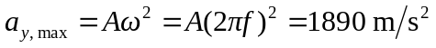
e) 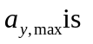much larger than g, so ok to ignore gravity.

